Welcome to the November issue of The Happy Home! Winter is right around the corner and in many places there’s a wonderful chill in the air. It’s a sure sign that the holidays are upon us.

Before it gets really cold, this month it’s a good time to check the energy efficiency of your home to make sure the warm air isn’t seeping out and the colder air isn’t coming in. We’re sharing some tips to get you started.

Tired of the same old side dishes on Thanksgiving? We’re sharing a recipe for wild rice with cranberries that you can make in your slow cooker. You just add the ingredients and turn it on. It’s a delicious twist on a side dish that leaves you free to tend to your other Thanksgiving festivities.

Sure, the food and gifts might be the stars of the holiday season, but we all know it's really about giving something from the heart. Read our articles about the boy who traded his gizmo-packed gift list for feeding the homeless and our tips for reducing stress during the holidays.

At this time of year, we want to express our gratitude for wonderful customers like you. Without you, there would be no us…so thank you!

“Gratitude is the inward feeling of kindness received. Thankfulness is the natural impulse to express that feeling. Thanksgiving is the following of that impulse.”
~Henry Van Dyke

Is Money Slipping Out of Your Home?

One of the best ways to save a few bucks on your monthly bills is to make your home more energy efficient. This way you're saving significant amounts of money over time. There are a number of very simple and inexpensive things that you can do around your home all year long to accomplish this.
Air Filter Replacement
Your heating and cooling system is the biggest user of energy in your home. So it only makes sense that it should run as efficiently as possible. Pay attention to the air filter; a dirty filter restricts air flow, makes your heating and cooling system work harder and will end up costing you more money each month. Changing the filter regularly will ensure the system is operating as efficiently and inexpensively as possible.
Digital Programmable Thermostat
Another way to maximize your current heating and cooling system is by installing a digital programmable thermostat. This will make sure that your home is warm when you want it to be, and not unnecessarily when you are away from home.
It's a perfect way to save money year round. If you're at work during the day the programmable thermostat will allow you to adjust the temperature while you're away and just before you arrive home the system will kick on and bring your home to a comfortable temperature. By dropping the temperature in your home by just a few degrees while you're away you can save you up to 30% on your heating and cooling bill.
Insulation
One of the best ways to increase the energy efficiency of a home is to add another layer of insulation if there isn't enough. To determine if you have enough insulation in your attic, measure the existing amount of insulation. If there is less than twelve inches, you most likely need additional insulation. In colder climates you may even need as much as fifteen inches in your attic.
Energy Efficient Window Replacement
It's hard to have an energy efficient home without energy efficient windows. Poor quality drafty windows can make a big impact on your energy bill. A popular selection for many new homes as well as renovation projects is vinyl windows.
Vinyl windows have several advantages. Unlike metal windows, a vinyl window will not allow the temperature outside to transfer to the inside of a home. Vinyl windows also typically have double paned glass. This means there are two pieces of glass with an air space between them making a much more efficient unit and incorporating sound deadening qualities.
Appliance Selection
Over time, the energy cost to run appliances can be many times greater than the upfront cost. Most of the appliances being sold today are up to 50% more efficient than they were 10 years ago.
To make sure you're getting the most efficient appliance look for the energy star label. This will ensure that it is the most efficient in that category of appliance. If it's not in your budget to buy new appliances at least make sure your existing appliances are as efficient as possible.

Slow Cooker Wild Rice with Cranberries
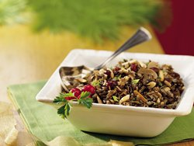
1 ½ cups uncooked wild rice
1 tablespoon butter or margarine, melted
½ teaspoon salt
¼ teaspoon pepper
4 medium green onions, sliced (1/4 cup)
2 cans (14 ounces each) vegetable broth
1 can (4 ounces) sliced mushrooms, undrained
½ cup slivered almonds
1/3 cup dried cranberries

- In 2- to 3 1/2-quart slow cooker, mix all ingredients except almonds and cranberries.
- Cover and cook on low heat setting 4 to 5 hours or until wild rice is tender.
- In an ungreased heavy skillet, cook almonds over medium-low heat 5 to 7 minutes, stirring frequently until browning begins, then stirring constantly until golden brown and fragrant; set aside. Stir almonds and cranberries into rice mixture. Cover and cook on low heat setting 15 minutes.

Expert Tips: Many supermarkets now carry a wide variety of dried fruits. Dried blueberries or cherries are delicious substitutes for the cranberries. Toasting the almonds not only enhances their flavor and color but also helps prevent them from becoming soggy after they are stirred into the wild rice mixture.

Recipe and photo compliments of www.BettyCrocker.com.

Weird and Wacky!

- An ostrich's eye is bigger than it's brain.

- The planet Earth is the only planet not named after a god.

- The city Rome is located on every continent.

- Dolphins sleep with one eye open.

- If you were to drive 100 miles per hour, it would take you 29 million years to reach the Sun!

- The human brain is 80% water.

- There is no full word for "Mrs."

- Cat's urine glows under a black light.

- A dragonfly lives for only 24 hours.

- Children who are breastfed have been proven to be smarter than those who have not.

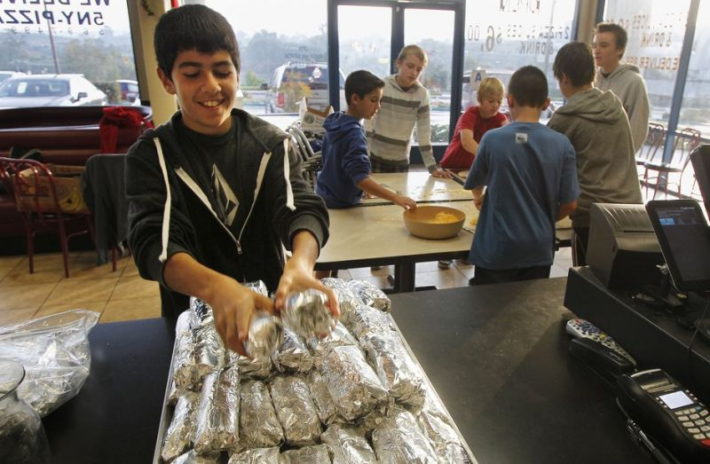
Teens Deliver 33,000 Burritos to the Homeless

A group of teens known as the "Burrito Boyz" has made and delivered more than 33,000 breakfast burritos to local homeless people. But it took a mentor to inspire them. Let's call him Burrito Dad.

Michael Johnson grew somewhat alarmed at son Alec's gizmo-packed Christmas list two years ago, so he decided to impart some perspective. According to Yahoo, he and his wife thought feeding the homeless might do the trick. Thus, the family and Alec's friend set about wrapping 54 egg-and-cheese burritos one Sunday in November and handed them out.

More than 130 Sundays later, their nonprofit Hunger 2 Help is rolling in good will. It has grown to seven Burrito Boyz and other volunteers, all of whom help make hundreds of tortilla-wrapped meals. They operate out of Johnson's business, Long Island Mike's Pizza, and distribute the food to a neighborhood in need.

Johnson said in the San Diego Union-Tribune in 2011 that they originally planned the charitable venture for a few months. But after that first week, they knew they weren’t going to stop. He noticed changes in his son from the start of their burrito mission, stating that the experience has changed him from a boy to a young man.

Think about it…what can you do to help someone less fortunate this holiday season?
5 Tips for Reducing Holiday Stress

Talk about stressful. The average American spends 42 hours a year on holiday activities. That's one standard workweek spent shopping, wrapping, and returning presents, attending holiday parties, and traveling from place to place. Often these extra activities get squeezed into already busy schedules.
This year, take the pressure off. Here are some tips to help you relax this holiday season.
1. Create the Holiday You Want
When the holidays come around, there may be pressures pulling you in all directions off your center. Make clear decisions about how you want to spend your time and resources. Do it early, before the decorations go up around town. Consider what is most important to you. What memories will you look back on when the season winds down?
2. Beware of Shopping Pitfalls
Shopping -- especially if you're worried about money or getting elbowed in the stores -- can drain the fun out of the holiday season. People who focus on gifts generally feel less holiday cheer than those who spend more time with close friends and family.
3. Get Creative in Your Gift Giving
Many families have had to cut back on holiday gifts. If this includes you, have a family meeting and get creative. Some families draw names and each person buys for one person. Some families do handmade gifts or coupons that are good for a massage or night off from doing the dishes, for instance. You don't have to go into debt to make the holidays special.
4. Play Games
Games can keep things fun and light at family gatherings and they are a good way to connect with each other and engage your mind, body, and imagination. The game is up to you; the key thing is, you are in the moment.
5. Have Compassion for Yourself and Others
Even if you shop less and focus on family time, stressed-out friends, in-laws, and co-workers may still come calling. How can you be a good friend and keep your calm?
Try not to take things personally. During the holidays in particular, most people are trying to get their needs met. Maybe it's their need for love or simply for validation. So try not to think about how people "should be." Accept them as they are, and release the tension from your body.

