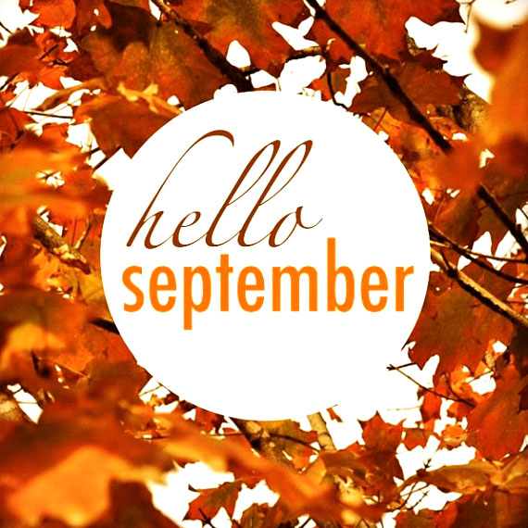
Welcome to the September issue of The Happy Home! It’s hard to believe that fall is right around the corner and we’re approaching the holiday season again already, isn’t it?

You know, September is a great time to catch-up on the home maintenance work that you put aside during the fun-filled summer months. So we’re giving you a short list to get you started.

And with the kids back at school, your days are probably a lot busier with after-school activities and homework. So we’re sharing a great recipe that you can put in the crockpot and forget. It will welcome you and your family home to a heavenly scent and a delicious meal.

When you think of Albert Einstein, you probably think…genius. But did you know that he was a high school dropout who failed his first college entrance exam, and had to go to a secondary school? We thought that was really interesting so we created a list of 10 more of our favorite fun facts about Albert Einstein for your amusement and edification.
We’re also sharing 3 more inspiring stories of ordinary people doing extraordinary things to transform their dreams into reality.
We hope you enjoy this month’s issue and that you are your family are enjoying the wind down from summer!

“Learn to enjoy every minute of your life. Be happy now. Don't wait for something outside of yourself to make you happy in the future. Think how really precious is the time you have to spend, whether it's at work or with your family. Every minute should be enjoyed and savored.”
~Earl Nightingale

September is a Catch-Up Month!
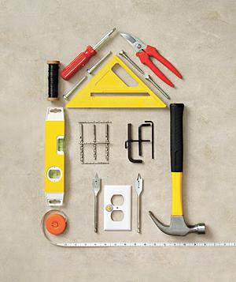
It’s a time to finish projects that you started during summer that were never completed. And it’s an excellent opportunity to see what can be improved, replaced, or repaired while the weather is still nice enough for outdoor projects.
This is also the perfect month to begin your fall home maintenance checklist, add seasonal color to your garden, and bring organization to your home—and your life.
1. Get a jump on fall home maintenance. While you were having fun in the sun this summer, it was no vacation for your house. A fall checklist will tip you off to little problems before they become nasty mid-winter surprises. The easiest way to do it is to check from top to bottom. Start with the roof—are your shingles worn? Check for leaks around skylights, vents, and chimneys (and have that chimney cleaned). Clear out your gutters and check for leaks there, too.
2. Add seasonal color to your garden. With summer blooms fading, this is the perfect time to boost your garden’s color sense. Mums are a popular choice, and for good reason—they are abundant, easy to care for, and colorful. But consider some other “stars” of the fall landscape, among them Black Eyed Susans, Leedplant, Ornamental Kale and other colorful options.
3. Organize your garage. If your garage has become a catch-all for miscellaneous storage, leaving little to no room for the family car, then now is the time to restore order. Purge items you no longer need and create a plan that will allow you to store more things you do need in a logical way that allows for easy access later on. Look for smart solutions that take advantage of the walls and ceilings and free up valuable floor space. Also, take the guesswork out of locating stored items and be sure to label everything.
4. Host an end-of-summer yard sale. Looking to clear the clutter (perhaps from your garage)? Make the most of the mild weather to host an end-of-summer yard sale. While it may not put a lot of change in your pocket, it will certainly free up some storage capacity and put your unused goods back into useful circulation.
5. Analyze your space: Now is also a good time to start considering how your home is going to hold up with holiday guests. Do you need some additional space? Could your guest bathroom or kitchen use an upgrade? If so, now is the time to contact a professional and get your plans in motion!

Slow Cooker Family Favorite Lasagna

Ingredients
1 lb. lean (at least 80%) ground beef
1 jar (26 to 28 oz.) tomato pasta sauce
1 can (8 oz.) no-salt-added tomato sauce
½ package (9-oz. size) no-boil lasagna noodles (about 8)
1 jar (1 lb.) Alfredo pasta sauce
3 cups shredded mozzarella cheese (12 oz.)
¼ cup grated Parmesan cheese

- 1. In 10-inch skillet, cook beef over medium-high heat 5 to 7 minutes, stirring occasionally, until thoroughly cooked; drain.
- 2. Spray 4- to 5-quart slow cooker with cooking spray. Spread 3/4 cup of the tomato pasta sauce in bottom of slow cooker. Stir remaining tomato pasta sauce and tomato sauce into beef.
- 3. Layer 3 lasagna noodles over sauce in slow cooker, breaking noodles as necessary. Top with 1/3 of the Alfredo pasta sauce, spreading evenly. Sprinkle with 1 cup of the mozzarella cheese. Top with 1/3 of the beef mixture, spreading evenly.
- 4. Repeat layering twice, using 2 lasagna noodles in last layer. Sprinkle Parmesan cheese over top.
5. Cover; cook on Low heat setting 3 hours 30 minutes to 4 hours 30 minutes. If desired, cut into wedges to serve.

Recipe and photo courtesy of www.BettyCrocker.com.

Our Top 10 Favorite Albert Einstein Fun Facts

1. Einstein was divorced from his first wife for adultery (his) and his wife received the Noble Prize money. The adulteress, Elsa, whom he later married, was his first cousin!
2. In less than one year, 1905, Einstein wrote the Annus Mirabilis Papers (from Annus Mirabils, Latin for 'year of wonders', but commonly referred to as 'miracle year'. These are some of the most important scientific papers in history, which ultimately provided the foundation for all of modern physics.
3. Einstein was born with an abnormally big head. Combined with his late start in speaking, doctors were concerned he might be retarded.
4. Hitler considered him public enemy number one.
5. Refusing the Presidency of Israel, he said, "I know a little of science, but nothing about men."
6. After his death, Einstein's brain was removed during the autopsy, against his wishes. It later took a bizarre cross-country tour in the trunk of a car and remains an object of morbid fascination.
7. Wildly cheered attending the Hollywood premier of the movie City Lights, Charlie Chaplin told him, “They cheer me because they all understand me, and they cheer you because no one understands you."
8. Two of Einstein's least favorite things: Haircuts and socks.
9. Two of Einstein's favorite things: The violin and sailing.
10. Einstein actually won his 1921 Noble Prize in Physics for the photoelectric effect. His theory of relativity was not only considered too radical for the powers that be, almost no one in the world truly understood it at the time.

3 More Ordinary People Doing Extraordinary Things

1. In January 1998, Ryan Hreljac learned for the first time that many people around the world do not have access to clean water. Although he was only in the first grade, he decided to do something about it.

His goal was to raise enough money to build a well in an African village. He thought it would cost about $70, and his parents agreed to pay him for extra chores so he could earn the money. It took him four months, and by then he had discovered that building a well actually would cost $2,000, so he started speaking to service clubs, school classes, and raising money any way he could.

That first well was built at Angolo Primary School in northern Uganda in 1999, when Ryan was 7 years old. In 2001, the Ryan’s Well Foundation was formed, and since then it has helped to build more than 740 water projects and 990 latrines, bringing water to nearly 800,000 people.
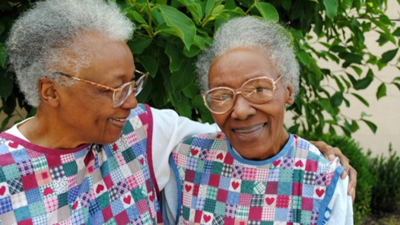
2. Twin sisters Helen Ashe and Ellen Turner grew up poor, but their parents always taught them to be generous with whatever they had.

In 1986, the sisters founded the Love Kitchen in Knoxville, Tennessee, in the basement of a small church. Their goal was to provide meals for those they call the five H’s: the hungry, the homeless, the helpless, the hopeless and the homebound. That first day, they prepared 22 meals.

Today, they serve more than 2,000 meals every week and the sisters, now in their mid-80s, are still going strong.
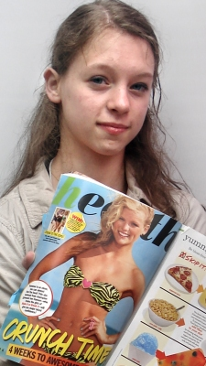
3. When 14-year-old Julie Bluhm noticed that all the girls in her ballet class thought they were fat, she decided something had to be done.
She blamed the unrealistic images girls are told to emulate—the kind of marketing that researchers say leads to eating disorders and self-harm among teenaged girls—so she wrote to Seventeen magazine asking the editors to stop using Photoshop to make all of their models look thinner and to publish one unaltered photo of a model each month.
She also started an online petition that garnered more than 84,000 signatures. In August 2012, Seventeen Editor-in-Chief Ann Shoket wrote a letter to readers saying the magazine would not alter the shape of its models’ bodies or faces, and would “celebrate every type of beauty.”

