Welcome to the June issue of the Happy Home Gazette! Summer is finally here and we couldn’t be happier!
With summer comes warmer weather and warmer weather means higher energy bills. Did you know that the average American household spends roughly $2,200 per year on home energy costs? In light of this we’re sharing some energy-saving tips to help you save some green this season.
Father’s Day is on June 21, so we’ve included some fun facts about this time-honored holiday. We’re also sharing a great recipe for grilled steak and vegetables. Give dad the day off from the grill and prepare this easy and delicious meal for him!
We’re also sharing some ideas to help keep the kids busy now that school is out for the summer. And be sure to check out the story about Andy Anderson. He’s lived almost a decade and shares some of his best tips for a long life.
Have you been referring us to family and friends? We hope so because our next Referral Rewards drawing will be held on September 1st and the grand prize will be the exciting new Apple watch...so get those entries in!
We hope that you and your family are enjoying the warmer weather and getting ready for some summer fun!

“Dad taught me everything I know. Unfortunately, he didn't teach me everything he knows.”
~Al Unser

Grilled Italian Steak and Vegetables

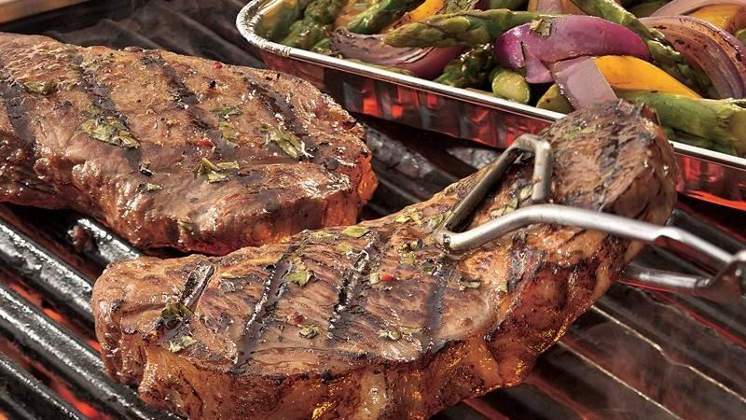
½ cup balsamic vinaigrette dressing
¼ cup chopped fresh basil leaves
1 ½ teaspoons peppered seasoned salt
2 beef boneless New York strip steaks, about 1 inch thick (8 to 10 ounces each)
1 pound asparagus spears, cut into 2-inch pieces
1 medium red onion, cut into thin wedges
1 yellow bell pepper, cut into 8 pieces

- 1. Mix 2 tablespoons of the dressing, 2 tablespoons of the basil and 3/4 teaspoon of the peppered seasoned salt in large bowl and set aside. Mix remaining dressing, basil and peppered seasoned salt in shallow glass or plastic dish or resealable plastic food-storage bag; add beef. Cover dish or seal bag and refrigerate 15 minutes.

- 2. Heat coals or gas grill for direct heat. Add asparagus, onion and bell pepper to reserved dressing mixture; toss to coat. Place in disposable 8-inch square foil pan or grill basket. Reserve dressing in bowl.

- 3. Remove beef from marinade; reserve marinade. Cover and grill pan of vegetables 4 to 6 inches from medium heat 5 minutes. Add beef to grill next to pan. Cover and grill beef and vegetables 10 to 12 minutes, turning beef once and stirring vegetables occasionally, until beef is desired doneness and vegetables are tender. Brush beef with reserved marinade during last 5 minutes of cooking.

4. Add vegetables to bowl with reserved dressing; toss to coat. Cut beef into thin slices. Discard any remaining marinade. Serve vegetables with beef. Drizzle with additional dressing if desired.
Engage Your Children in Some Easy Summer Fun!
Summer has really just begun, little league baseball is over, vacation is still weeks away, and the kids are bored. The heat is becoming oppressive, which can lead to irritability, whining, and fighting.
We don't always have the time to prepare and supervise elaborate projects, and when everyone is tired and bored, parents need something engaging with a minimum of preparation and fuss. So, keep these quick ideas handy and have a little fun on a long summer afternoon.
Make homemade ice cream. This is amazingly simple for such a special treat. You can get an ice cream maker for about $20. Make your favorite flavor and let your kids prepare toppings that they like.
Do TV/Web project. Find an educational - but interesting - TV program for the family to watch together and then research the topic on the Internet. See how many fun facts you can find about their chosen topic.
Make a fort. Remember how much you loved making a fort when you were a kid? Chances are good that your child will love it too! Use sheets, blankets, or comforters over tables and chairs. Put a lamp, pillow, books, games, and snacks in the "tent".
Go to the library. Plan on staying there for a while. Your kids can read or play on the computer, and you might find a new software program that the library uses that you want for use at home. Check out a variety of books and audio and videotapes to entertain the children for several days.
Go to the mall. Desperate times call for desperate measures, and an air-conditioned mall isn’t necessarily a bad thing. Going to a video arcade and getting an ice cream cone can keep your kids happy and content. And it’s great having everything under one roof!

Energy-Saving Tips for Summer
Summer is upon us, and while we all love the milder weather, chances are that your home energy costs may be rising. It’s always a great idea to save money any way you can, so consider the following ideas to make your electric bills more manageable this summer.
1. Adjust the thermostat. Air conditioning costs a fortune, and if it runs around the clock, you can surely expect a huge bill. To reduce the expense, gradually raise the temperature of your thermostat by at least three degrees, which will save you approximately 20 percent on your summer electric bills.
2. Request a home energy audit. Many power companies can come to your home and perform a home energy audit for free. The audit typically takes about an hour, and the tips and advice provided can help you save a significant amount.
3. Switch providers. If the power industry has been deregulated in your state, you have options of where to purchase your electricity. Review your bill and find out what you're paying per kilowatt-hour, and see if you can find a better rate.
4. Turn on ceiling fans. If you have ceiling fans, utilize them. They cost pennies to run, and by doing so, your air conditioning unit runs more efficiently. If you don't have them, consider installing them—it's a one-time cost that will pay for itself quickly. Just be sure to run your fans counter-clockwise in the summertime, as this draws cooler air upward.
5. Adjust your habits. Typical household duties, such as running the dishwasher or washer and dryer, can significantly heat up your home and run up your electric bill during each use. Consider doing these chores during the early morning or late evening hours to minimize the effect on your cooling bills. Furthermore, only wash full loads of laundry, and only run the dishwasher when it is entirely full. By using these appliances less, you save even more money on your monthly utility bill.
6. Open and close doors and windows. Track the hourly local temperature, and determine at what time the outdoor temperature will rise above the desired temperature inside your home. Open the doors and windows early in the morning, and don't close them until the outside temperature reaches the level of your thermostat. In the evening, open your doors and windows to let in the cool night air. This lessens your reliance on air conditioning.
When it comes to saving money, hitting a financial home run is always great—just don't ignore the small ways to save. Even if you only save 10 percent, you'll still have an extra $220 in your pocket at the end of the year.
You don't need to make a huge sacrifice to save money. Reducing your electric bill only requires a change in habits. By putting some or all of these ideas into place, you're likely to see your energy bills taking a smaller chunk out of your checking account each month.

- Father's Day By The Numbers

- Nearly 95 million Father’s Day cards were given last year in the United States, making Father’s Day the fourth-largest card-sending occasion.
- Sons and daughters send 50 percent of Father's Day cards to their dads.
- Nearly 20 percent of Father’s Day cards are purchased by wives for their husbands. That leaves 30 percent of the cards that go to grandfathers, sons, brothers, uncles and “someone special.”
- While not everyone in America is a fan of Father's Day, nearly 75 percent of Americans plan to celebrate or acknowledge Father’s Day.
- Neckties are an old standby and lead the list of Father’s Day gifts. A good place to buy dad a tie or a shirt might be one of 8,111 men’s clothing stores around the country.

Important Things Learned Over a Decade

Andy Anderson is a 99-year old great-grandfather. His life story is one for the ages. He met his wife on a Saturday, and they married on the following Saturday. They stayed together for the next 67 years until she passed away.

In between those 67 years, they had two children, adopted another son, and were the greatest party throwers in the county. Without going to college, Andy worked his way to the top; he became the corporate manager of the dairy department of Safeway for the entire country.

He earned the nickname Mr. Cheese, which eventually turned into Grandpa Cheese among the family - a name that has admittedly raised a few brows. Here are some of the most important things he has learned in his 99 years.

- Always maintain a good sense of humor.
- Never be too good to start at the bottom.
- Love at first sight is not a fable.
- Your family is the most precious thing you will ever have in life.
- Your life is delicate, and if you neglect yourself, you'll spoil. That's what cheese taught me.
- Don't ever be afraid to be your true self.
- You must be able to forgive, even if it's difficult to do.
- Save your money now and spend it later.
- Love is not always easy; sometimes you have to work at it.
- Find something comical in every single situation.
- Make sure you're doing what you love; don't be afraid to follow those dreams you have for yourself.
- Explore your world and stay curious.
- Try not to take yourself so seriously.
- Have common sense. Think about the most reasonable answer to every situation. If you don't have common sense, you're a bust.
- Life is a gift that you must unwrap. It's up to you to determine if what's inside will lead you to happiness or dismay. You have the power to make that decision for yourself.

